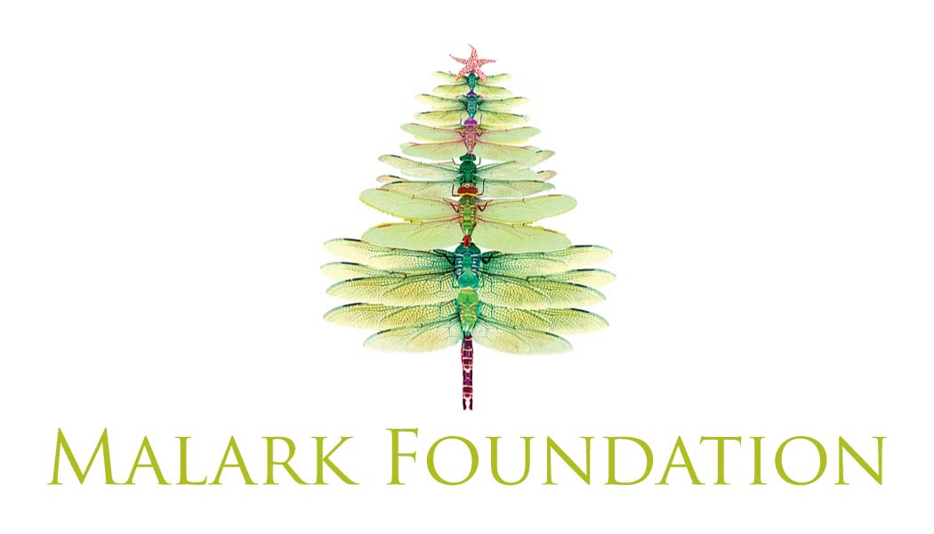

The Malark Foundation Grant Application

Part A: Contact Information
Name of Organization _________________________________________________
Address (line 1) _________________________________________________
Address (line 2) _________________________________________________
City, State Zip _________________________________________________
Website _________________________________________________

Primary Contact Person _________________________________________________
Title _________________________________________________
Address (line 1) _________________________________________________
Address (line 2) _________________________________________________
City, State Zip _________________________________________________
Phone (________)________-__________
Email _________________________________________________

Part B: Program Summary
Please attach a separate piece of paper with responses to the following questions

1. Describe the mission and activities of your organization.
2. What is the total budget for your organization?
3. Describe any particular activity or project this grant would fund. Please explain who will be served by this program and the project’s budget.
4. What is the amount of the request? Please explain this amount.
5. Please provide any other additional relevant information.

Part C: Signature
I agree that all information provided is to the best of my knowledge true and complete, and I understand that any misstatement, falsification, or omission of information is grounds for denial.

Signature: _______________________________________ Date: ___/___/___

